Safety in the Stained Glass Studio

Stained Glass is a unique and rewarding hobby, but it isn’t without its risks. When you work on stained glass pieces you are cutting and handling sharp glass as well as extremely hot soldering irons. You also come into contact with various chemicals. It is extremely important to practice caution when you work on your piece.
Here is a list of our recommended stained glass studio safety tips so that you may enjoy making your creations confidently and safely for years to come.

What to have in your workspace
The first step to glass studio safety is to have the proper workspace set up.
- Have a good light source. It is much safer cutting and handling glass and using a soldering iron when you can see well.
- Be sure that your work table is sturdy and not wobbly to avoid any possible injuries and/or mistakes while working.
- A rubber-backed rug under your work area is a good idea if you don’t have your own fixed workspace. This makes clean up easier and keeps glass from spreading throughout your home.
- For your glass waste, use a separate sturdy bin and dispose of it separately to avoid any cuts when taking out the trash.
- Keep a dust pan and brush on hand to clean up glass shards. Never swipe them with your hands!

Keeping a basic first aid kit in your studio is a good idea when you work with glass. This is a list of items you should include in your kit.
- Antiseptic
- Band aids
- Gauze pads
- Bandage tape
- Tweezers for removing glass splinters
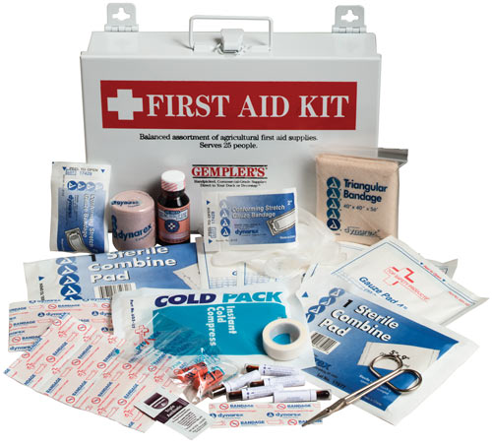
- Eye wash

How to dress when working on stained glass
As far as clothing goes, you can wear pretty much whatever you wish, just practice caution when handling glass and hot tools so as not to injure any exposed areas. There are, however some items that you should consider wearing every time you work.
- Safety glasses, to protect your eyes from being hit by small fragments of glass, flux, and other such things. If you wear prescription glasses, you may want to consider to wear the safety glasses still (double the protection), but it is not as important.
- If you have sensitive lungs, you may want to consider wearing a dust mask when grinding and cutting glass. The dust that may be produced can be aggravating.
- Wear old clothes that you keep exclusively for glasswork, or wear an apron to help keep glass from getting into your home. Wash these clothes separately from the rest of your laundry.
- Wear closed toe shoes! We cannot stress this enough. Protect your toes from sharp glass and hot solder that may fall to the ground.
- Gloves are optional. We personally do not usually wear gloves when we work, as we feel that they make you less responsive to the glass. If, however, you feel more confident when you don a pair of gloves, be sure that they have a snug fit and are rubberized to prevent the glass from slipping.
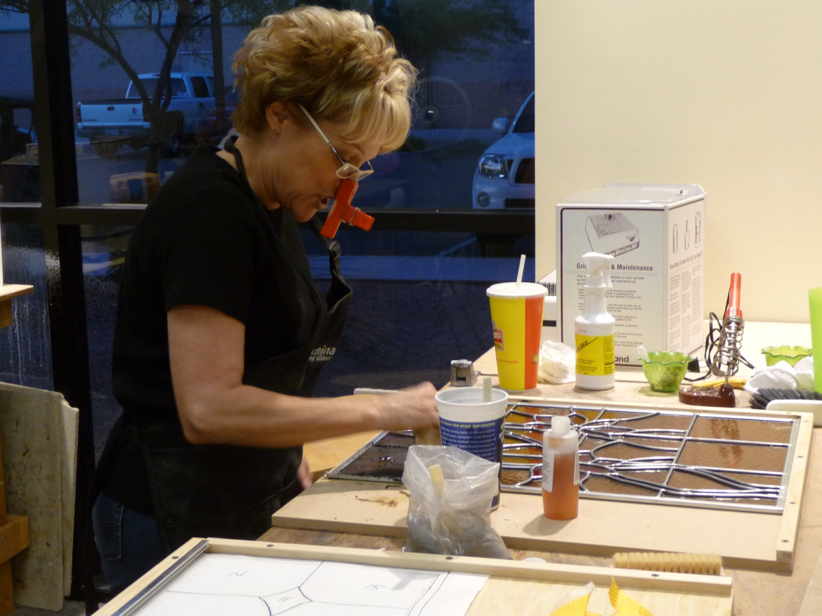

Handling Glass Properly
When you handle the glass properly you make it easier to avoid injury. Handle the glass with “soft hands.” Move slowly and handle it gently, and you are unlikely to hurt the glass or yourself. Whenever you hold a sheet of glass, keep it in the vertical position with one hand on the bottom and one hand on the side. It is also best to store your glass in a vertical position. It is harder to pick up from a horizontal position as well as more vulnerable and prone to breaking. Remember, if you drop any glass, do not try and catch it! Just move quickly out of the way to avoid injury.

Never hold the glass above your head to look at it. Instead place it on a windowsill to get a good look at it.

Soldering Safety
Safe Soldering Practices
- Tie long hair back
- Stay focused and concentrate at all times, always look before you pick up a hot soldering iron
- Don’t overuse the flux, this can cause the hot solder to splatter as well as cause more fumes
- Solder on fire/heat-resistant surfaces
- Use a soldering iron stand for resting your hot iron on, never rest a hot iron on your workspace
- Be sure that the soldering irons wire is nowhere near the tip of the iron when you place it in the stand to avoid melting it
- Never leave a hot iron unattended
- Before you turn your project over to work on the opposite side, be sure the solder has had some time to cool so as not to burn yourself
Fumes and Ventilation while Soldering
When you are soldering, the flux burns off and emits some fumes. It is best to try and avoid breathing in the fumes. They can be largely avoided by making sure you have adequate ventilation. Work in a large open space, avoid tight and airless spaces. If you can, solder near an open window, and consider using a fan to move the air out. If you are concerned that your space is not adequately ventilated, consider wearing a mask or respirator with filters that screen out vapors. As you solder you should always bend away from the fumes to ensure that you are breathing in as little fumes as possible. For further safety information you should always read and adhere to the manufacturers labels on your solder and flux products.

Do’s and Don’ts in the workspace
- Don’t allow pets into your work area. This is to prevent injury to them, and you, as well as keep them from spreading glass throughout your home.
- Don’t allow unsupervised children in your workspace! A glass studio is not the best place for a child.
- Don’t eat and/or drink when you’re handling solder, lead, and glass. These are not things you want to accidently ingest.
- Don’t touch your hands to your mouth or eyes when working on your piece.
- Do keep your work space tidy. Tidy workers avoid injury.
- Do follow all of the safety tips, and enjoy practicing your craft confidently.
- Do be alert. You don’t want to work when you are too tired, hungry or distracted in any way, or you may end up injured.
- Do keep calm. Take your time and enjoy each step. Rushing through your project will prevent you from working safely.
If you have any questions you are welcome to visit us on-line at http://www.kachinastainedglass.com/contact/, or in store at 1762 S. Greenfield Road #101 Mesa, AZ 85206. We are also available by phone, just call (480) 655-2000. We are happy to help you with any of your stained glass questions and needs Mondays from 9-5, Tuesdays and Wednesdays from 9-9, Thursdays and Fridays from 9-5, and Saturdays from 10-4. *Ask us about our available classes!

